**1. Introduction**

**1.1 Purpose**

The main purpose of application is to create, modify and delete online invitation system which helps the people to invite guests for their party to manage the number of people attending the event, creating polls to finalize food menu and what costume they have to wear. This application helps the event organizers to plan the event successfully without any issues.

**1.2 Scope**

The scope of the project is to create an application that helps the event organizers to invite the guests to party which helps the organizers to plan for the place, food items, number of guests, what are the lists of items they need to bring while coming to the party and what costume they have to wear.

**2. Project Objective:**

Here is a detailed overview of login page and register page and also the pages that we are going to work on this semester:-

1. Host
2. Register
3. Login
4. Send an invitation
5. Modify/Change an invitation
6. Cancel an invite
7. View card templates
8. Save the invitation for later use
9. View the number of hosts who confirm
10. Add a poll to an invitation
11. What to bring?
12. Add food menu
13. Add guests to the contact list
14. SMS invitation
15. Invitee
16. RSVP invite
17. Register
18. Login
19. View the invite
20. Similar functionalities as host

**Login Page:**

This is the home page that pops when any user enters our website on the left side of the page we have images and on the right they can see the sign in option if the user is already registered user then they enter their username and password. If they are new users they can use the register option to create an account. 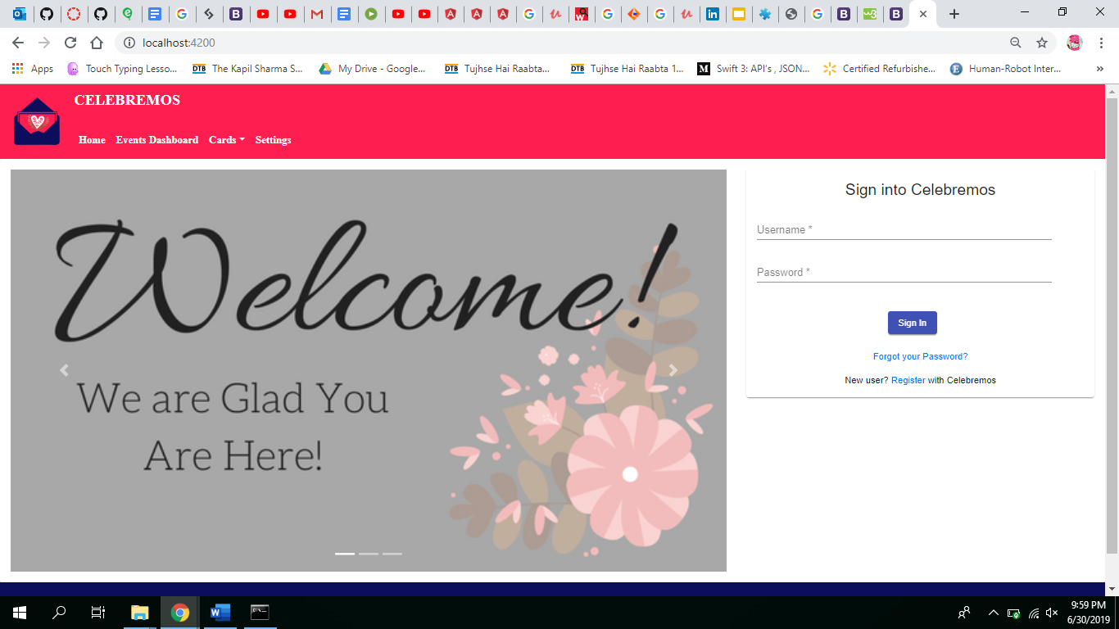

**Register Page:**

When a new user tries to use our page he needs to register for our website to be able to create an event. Here the user needs to give his details like first name, last name, username, email and password as well as password.

